Create backend and frontend applications

>> npx create-react-app my-app

Powershell permission issue

Assign permissions

>> Get-ExecutionPolicy

>> Set-ExecutionPolicy -ExecutionPolicy Unrestricted

Then create the app

Run the app

>> npm start

Error-

Delete package-lock.json and node-modules

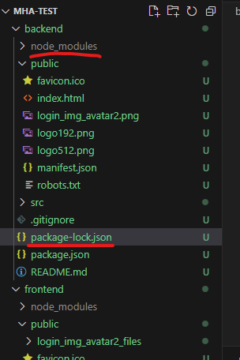

Go to “package.json” file and change the version for

"react": "^19.0.0",

    "react-dom": "^19.0.0",

And suitable version for

 "devDependencies": {

    "web-vitals": "^3.1.0"

  }

Build the backend app after checking it’s working good.

>> npm run build

And deploy to web app

Deployed backend and frontend to 2 different web site.

Still the default page exists.

Provide startup cmd for the app service

>> pm2 serve /home/site/wwwroot --no-daemon –spa

Check application accessibility.

Now, update the backend reg page and frontend login page with each other link to redirect correctly.

To update link go to app service, on default url right click and copy the url. Else the link will be corrupted.

Do the same for frontend and backend.

Working as expected and also added url ping to check availability.

Few times switched from login to register and register to login (back to front, front to back)

Requests are getting tracked.

Now I tried to track the actual client ip, from application insight logs. But, it does not shows the actual IP it shows the ip as global 0.0.0.0

Because by default the application insight masked all the IP.

To get client IP we need to set the DisableIpMasking property to true in your Application Insights resource.  
to do this go to application insight and search for automation.

And go for export template.

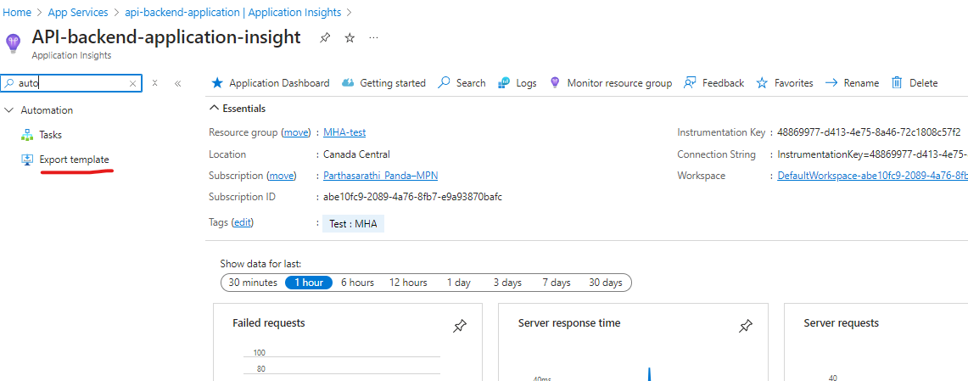

Go for deploy.

Go for edit template.

Under resource -> properties. Set “DisableIpMasking”: true

Now save the configuration and refresh. It will start tracking ip.

Go to log and search by query.

>>

requests

| where success contains "true"

Request send from own system tracked by IP and client state, rest request from health check.

Query to check dependencies.

>>

dependencies

| distinct id, client_Browser, client_IP, client_City, client_OS, data, resultCode, duration

We can also track all the transactions by Transaction search.

Configure Private DNS

Will configure DNS for frontend and then can send request privately to backend.

Create private DNS zone.

Add record here